**INSTALL ELASTIC SEARCH ON WINDOWS SERVER**

**Objective:** To install and configure Elasticsearch on Windows Server 2012 that will handle data traffic from 50 – 100 nodes.

**Requirements:**

* Windows Server 2012 (Member Server)
* A machine with 64 GB of RAM is the ideal sweet spot, but 32 GB and 16 GB machines are also common. Less than 8 GB tends to be counterproductive (you end up needing many, many small machines)
* Most Elasticsearch deployments tend to be rather light on CPU requirements. As such, the exact processor setup matters less than the other resources. You should choose a modern processor with multiple cores. Common clusters utilize two to eight core machines.
* Disks are important for all clusters, and doubly so for indexing-heavy clusters (such as those that ingest log data). Disks are the slowest subsystem in a server, which means that write-heavy clusters can easily saturate their disks, which in turn become the bottleneck of the cluster.

If you can afford SSDs, they are by far superior to any spinning media. SSD-backed nodes see boosts in both query and indexing performance. If you can afford it, SSDs are the way to go.

* A fast and reliable network is obviously important to performance in a distributed system. Low latency helps ensure that nodes can communicate easily, while high bandwidth helps shard movement and recovery. Modern data-center networking (1 GbE, 10 GbE) is sufficient for the vast majority of clusters.

**STEPS TO INSTALL AND CONFIGURE ELASTIC SEARCH**

1. Download the Elasticsearch from this website. <https://www.elastic.co/downloads/elasticsearch>
2. Click on Zip link.



1. Save the zip file to My Documents then unzip it on the same location.

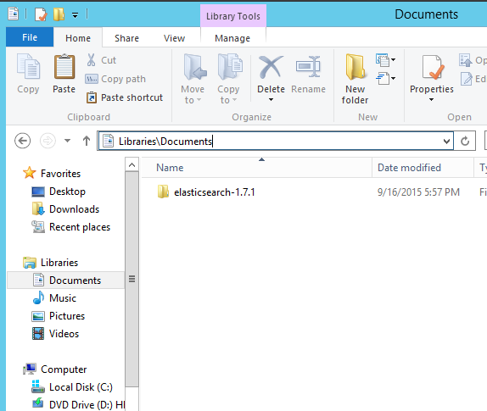

1. Copy the \Project\castellan\config\elasticsearch\**default-mapping.json** to C:\Users\Administrator\Documents\elasticsearch-1.7.1\config

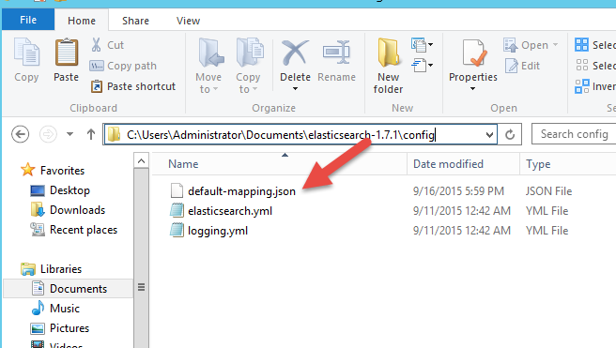

1. Right click on the elasticsearch.bat to run the application located in C:\Users\Administrator\elasticsearch-1.7.1\bin\elasticsearch.bat

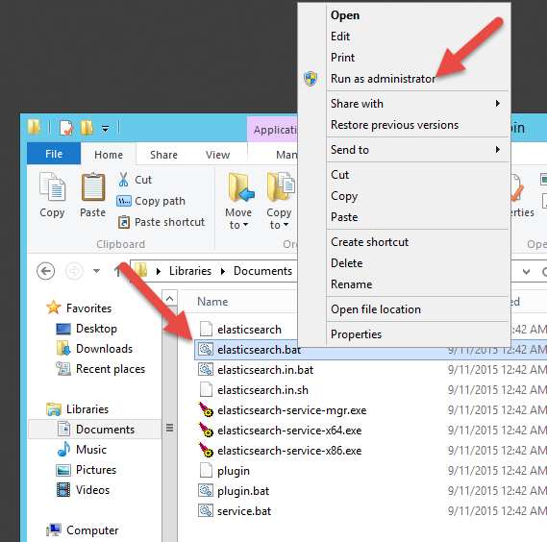

1. To handle 50 – 100 clients I recommend running 3 instances for Elasticsearch for load balancing purposes. To run another instance of Elasticsearch please repeat Step#5.

You can run these instances on different machine as long as they are on the same network. But I recommend to run these instances on one machine.

